**Super Special ROOT User**

**ubuntu@ip-172-31-10-134:~$ man rm**

**(we use rm command to remove our files)** 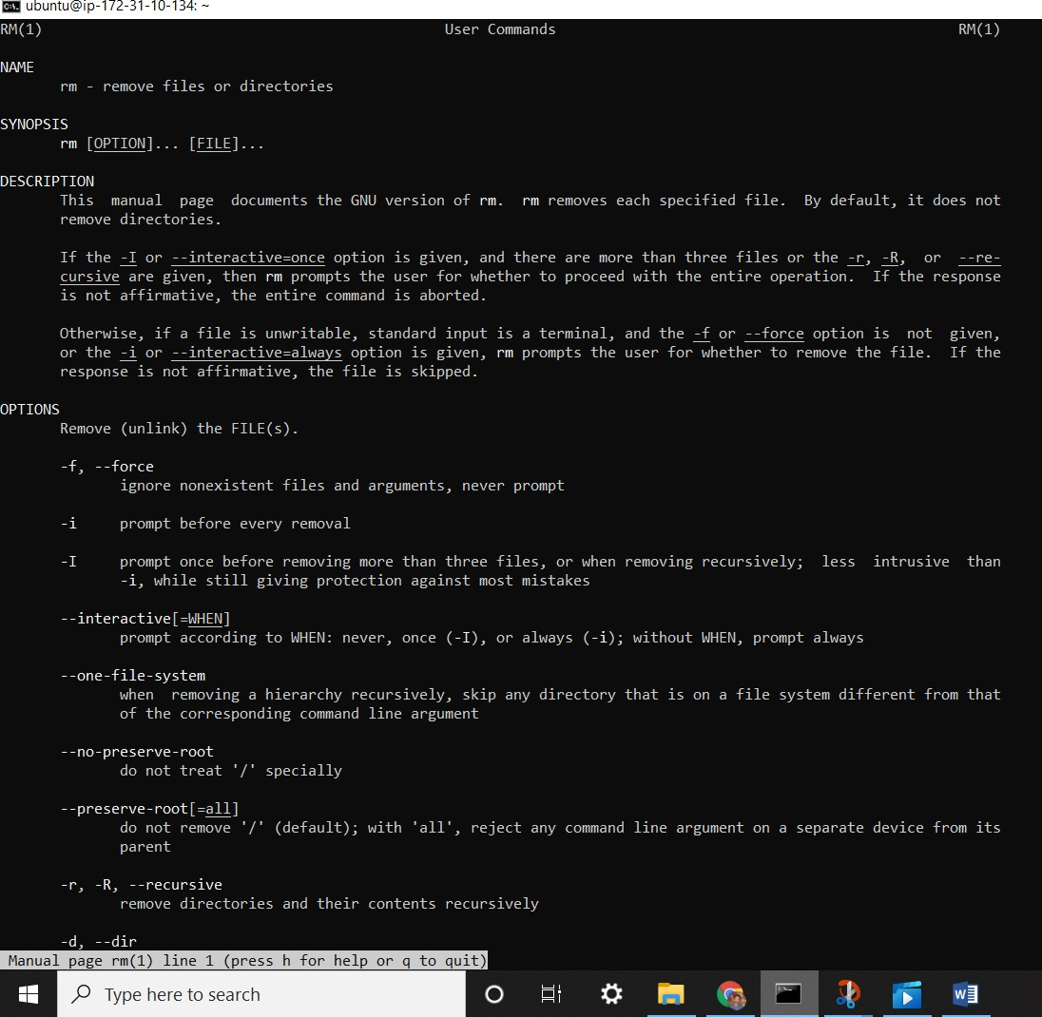

**ubuntu@ip-172-31-10-134:~$ ls**

**ThisFile.txt ThisIsFile.txt Thisfile.txt**

**ubuntu@ip-172-31-10-134:~$ rm -rf / home/theo/test**

rm: it is dangerous to operate recursively on '/'

rm: use --no-preserve-root to override this failsafe

(Doesn’t happen often but Ubuntu built this warning because it’s so dangerous if it does happen.)

**ubuntu@ip-172-31-10-134:~$ rm -rf / home/theo/test –no-preserve-root**

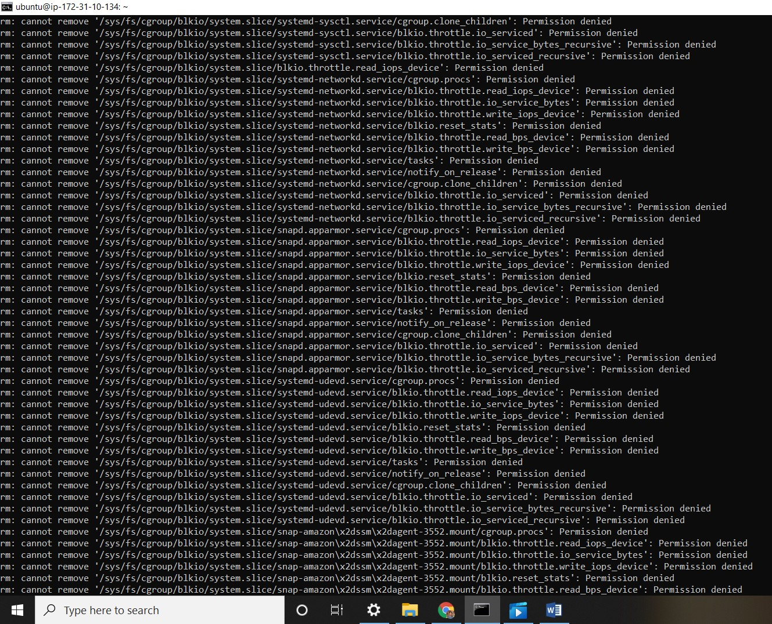

**ubuntu@ip-172-31-7-93:~$** cd /home

**ubuntu@ip-172-31-7-93:/home$** ls

Ubuntu

**ubuntu@ip-172-31-7-93:/home$** cd /ubuntu

-bash: cd: /ubuntu: No such file or directory

**ubuntu@ip-172-31-7-93:/home$** sudo su –

**root@ip-172-31-7-93:~#** exit

logout

**ubuntu@ip-172-31-7-93:/home$** cd ~

**ubuntu@ip-172-31-7-93:~$** sudo rm -rf /home/theo/test --no-preserve-root

(if you put this command you will lose your terminal history and terminal data)

**ubuntu@ip-172-31-7-93:/$** exit

logout

**ubuntu@ip-172-31-7-93:~$** history | grep shutdown

14 history | grep shutdown

**ubuntu@ip-172-31-7-93:~$** sudo su -

**root@ip-172-31-7-93:~#** pwd

/root

**root@ip-172-31-7-93:~#** exit

logout

**ubuntu@ip-172-31-7-93:~$** sudo cd /root

sudo: cd: command not found